AI BLOGNEST
Project Testing Phase
Date | 25/09/2026
Team ID | SWTID-2026-6744
Project Name | AI BlogNest

Team Leader : : KARTHICK M / Team Members : KANNAN G, SATHISH K ,
HARIHARAN S

PHASE 6: PROJECT TESTING PHASE
Testing tools: Postman or the ThunderClient VS Code extension. Start the backend server with: npm start

6.1 User Registration
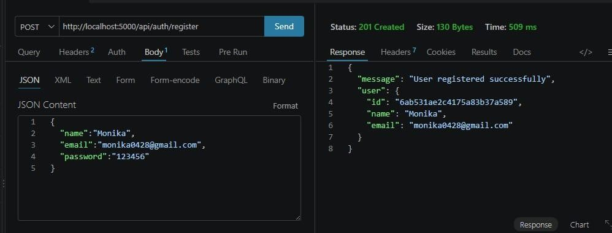
Fig 6.1 — User registration test 6.2 User Login
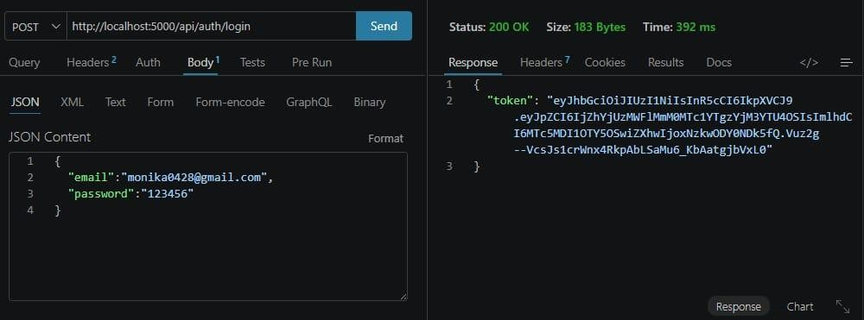
Fig 6.2 — User login test

6.3 Create Blogs
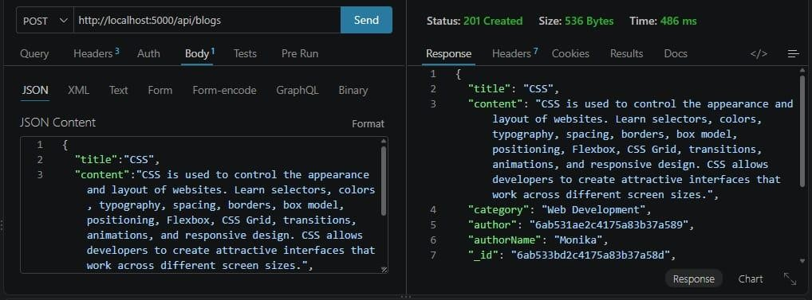
Fig 6.3 — Create blog test 6.4 Fetch Blogs
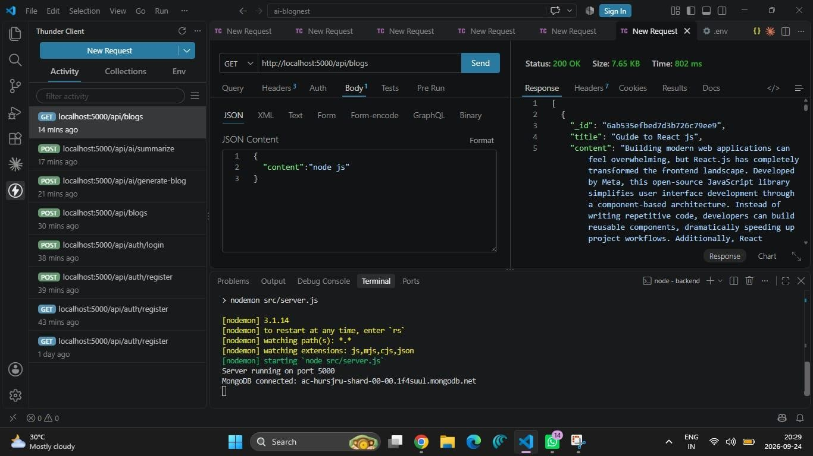
Fig 6.4 — Fetch blogs test

6.5 Generate AI Blogs
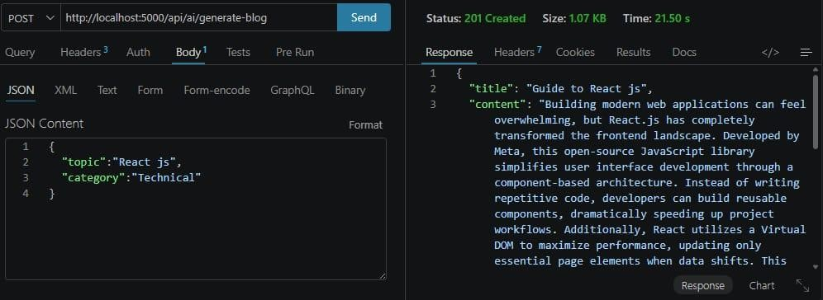
Fig 6.5 — AI blog generation test

6.6 Summarize Blogs
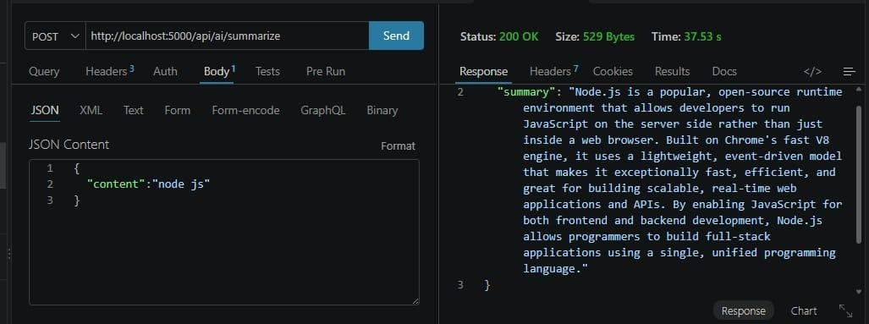
Fig 6.6 — AI summarization test

